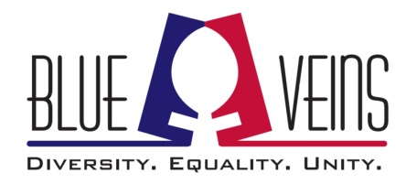
Report an incident at a Blue Veins event
We are extremely sorry that you experienced or observed an upsetting or unpleasant incident at a Blue Veins event. We'd like to know more about it, so that we can work to ensure that such incidents don't happen again.
There is no obligation to identify yourself on this form, but if you would like us to respond, please include your name and email address.
This form will be monitored throughout the event and beyond. There is no time limit for making your report. You may also speak to any member of the Blue Veins team during the event.
Your information will not be shared beyond Blue Veins' small team.
Optional
Name:
Optional
Email:
If you would like a response, please provide your name and email address
*Required
Details of the incident *
Please give as much information as you can, including exactly what happened, and (if relevant) the place and time, or links to online abuse. You may, but do not have to, provide details of any person who was responsible for this incident. This information will not be shared beyond the event's abuse management team.

What would you like the outcome of this report to be?
For example: Removal of the perpetrator from the event; warning sent to perpetrator that their behaviour is unacceptable; removal of offensive or upsetting tweet; no action to be taken, etc.

Would you like a response from the Blue Veins team? *
Yes No
Note: Kindly send the filled form to complaint@blueveins.org

